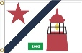
2013 Commodore’s Cruise
July 21th through July 26th
Henry Island to Ovens Island

Cruise Captains
Phil & Deanne Calvert 206-910-7977 Fred & Ann Pot 206-850-7664
Race Committee: M/V Portage Bay, Skipper: Denny Johnson & Bob Johnson, PRO: Lance Downing

Sunday, July 21 5:00pm Henry Island Green Box Party
Get Cruise bags and cruise/race instructions!
7:00pm BBQ by Chef PC (Please bring (A-K) side or salad
(L-Z) dessert)
8:30pm Bonfire and S’mores

Monday, July 22 11:00am Race from Henry Island to Sidney, B.C.
Stay at docks at Port Sidney Marina
Customs Check-in
5:00pm Greenbox on covered dock near the ramp
Wine and Rootbeer Tasting for best Chardonnay and Rootbeer-prize given to boat for best in class
Kids or Adults - best Root Beer tasting-prize given!
Dinner on your own! Great choices in Sydney!
Sailboat Awards and Rubber Chicken Award*

Tuesday, July 23 11:00am Race from Sidney to Ganges

Check in at Saltspring Marina
5:00pm Greenbox on outer dock-Best Hat contest-prizes given! Kids and
adults!
Sailboat Awards and Rubber Chicken Award*
Dinner on your own or arrangements are being made at Calvin’s Bistro (see below) if you if you desire.

Wednesday, July 24 Lay Day in Ganges
3:00pm rendezvous in Montague Harbor (everyone leaves around noon)
Perform Star Raft-Chris Warner & Denny Johnson in charge
5:00pm Greenbox-boat to boat.
6:00ish Fly over picture of Star Raft, please smile!

Thursday, July 25 11:00am Race from Trincomali Channel to Ovens Island
5:00pm Green Box Party
7:00pm BBQ Burgers and Chips and awards at
Ovens for overall race results! Sailboat Awards and Rubber Chicken
Award*
8:30pm Movie Night-Captain Ron (technology allowing)

Friday, July 26 8:00am Lead Sinker Pancake & Sausage Breakfast On the Docks at Ovens! Please everyone be prepared to use your boat BBQ or kitchen for cooking pancakes and sausages.

No Flying Sails; SYC handicapper will assign ratings for the Commodores Cruise.
M/V Portage Bay will be the Committee Boat with the official race committee. Every yacht receives a participation bag and burgee. Trophies for first three places in each class will be awarded each evening and overall on final night. Dockage at Port Sidney Marina is paid directly to the marina.
*Rubber Chicken Award: is given to the best boating maneuver, power or sail! An Honor to fly
on your spreader. Proper flag etiquette is also a major part of the Rubber Chicken. Beware!

Race Courses

Each of these races is point-to-point, and there are no marks of the course, except the start and finish lines. You may choose any route.

Monday
Start will be outside the North entrance to Roche Harbor. Look for “Portage Bay.” Course will be to Sidney Harbor, with finish to be in vicinity of harbor markers in Sidney Harbor. Distance will be approximately 10 miles.

Tuesday
Start will be outside the Sidney Harbor breakwater toward Ker Island to the North. Finish will be near entrance to Ganges Harbor, near Second Sister Island. Distance will be approximately 12 miles.

Thursday
Start will either be near Victoria Shoal in Trincomali Passage, or will be off Jackscrew Island in Houston passage, depending on the winds. Finish will be near Sharpe Point close to Ovens. Distance will be approximately 10 or 13 miles, depending on the course.

Race Instructions

Committee Boat: Portage Bay – Denny Johnson, Lance Downing & Bob Johnson

VHF Channel: Channel 72

Race Administrators: Denny Johnson & Lance Downing

Time Limit: 16:30 hours each day

Courses: As described above

Protests: Exonerate your protests with 720’s. If necessary, a Protest Committee will be convened. Protests to be filed within two hours of your finish.

Throw Outs: If three races are run, there will be one throw out.

Start Times and Sequence

The schedule for races is the same for each race day:

11:00 a.m. Warning for Class A (White Flag)
11:04 a.m. White flag comes down
11:05 a.m. Preparatory for Class A (A Flag)
11:09 a.m. A flag comes down
11:10 a.m. Start for Class A (B Flag)
11:14 a.m. B flag comes down
11:15 a.m. Start for Class B* (White Flag)

* Warning signal for first class generally recalled
** Preparatory signal for first class generally recalled

Code Flag “AP” Answering Pennant, with two signals means race is postponed.
General recalls shall be signaled by two sound signals. Recalled fleet shall clear the starting area. The start for the first recalled fleet shall be five minutes after the last scheduled start, and additional recalled fleets shall start in five-minute intervals in their proper sequence.

Retiring yachts shall notify the Portage Bay on VHF 72. Race scoring will be the low point scoring system. Scoring will be time on distance, using PHRF handicapping.

Trophies will be awarded for First, Second and Third place, and the week’s best performance in both classes.

Port Sydney Marina Map
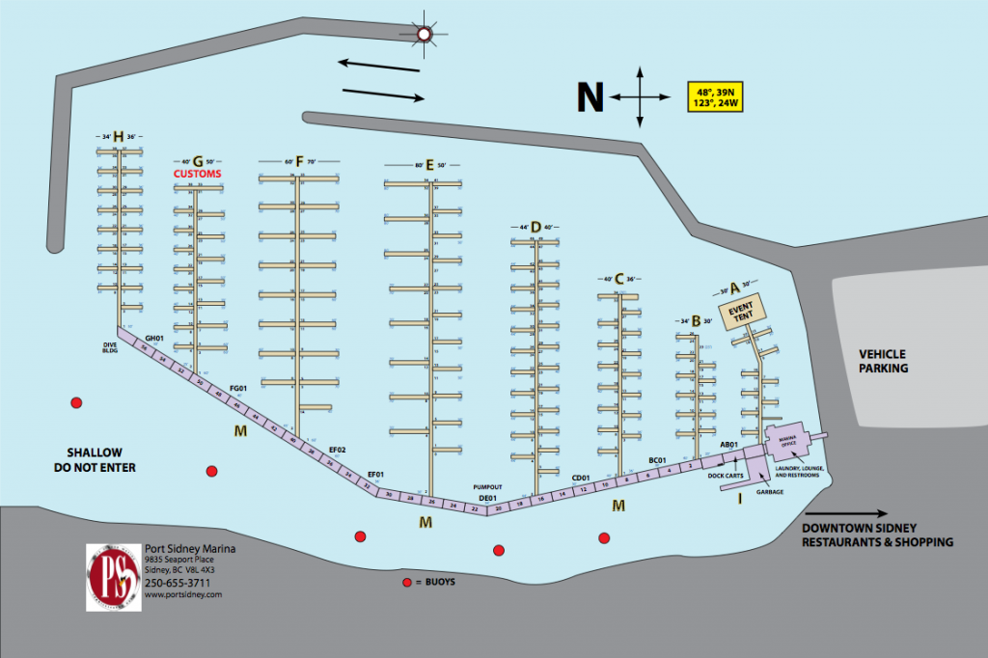
Mooring in Ganges
Please note the following preliminary docking plan:
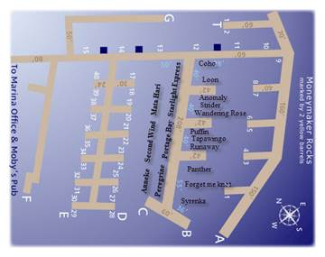
Dinner in Ganges
In the past Commodore’s Cruises we have been on our own for dinner in Ganges on Tuesday night. This year we arranged to have dinner together at Calvin’s Bistro. Chef René Widmer is offering us:
· Lobster Bisque
· Spinach Salad with Salt Spring Goat Cheese, Mandarins, Cranberries & toasted Almonds
· Choice of: Sockeye Salmon and local Ling Cod with Marinara sauce or Lamb Osso Bucco or Schnitzel with Mushroom sauce
· A selection of our homemade desserts

CA$30.- /pp plus tips and taxes

Let us know if you can’t make it to this dinner.

Class | Boat Name | Owner Name | Boat Type | Make/Model | Sail/Log Racing Number
Cruiser | ANNEKE | Pot, Fred | Sail | Catalina | 4383
Cruiser | COHO | Mundell, George | Sail | Jeanneau 43 DS
Cruiser | Flying Eagle | Sullivan, John (Jack) | Sail | Oyster Ketch
Cruiser | Forget Me Knot | Glockner, Donald | Sail | Beneteau 473
Cruiser | Loon | Clark, Taylor | Sail | Warwick
Cruiser | Panther | Warner, Chris | Sail | Swan-48 | 11220
Cruiser | Peregrine | Smolinske, Stephen | Sail | Catalina 38 | 46726
Cruiser | Second Wind | Haelsig, Richard | Sail | Moody
Cruiser | Tapawingo | Hansen, Ingrid | Sail | Tartan
Cruiser | Wandering Rose | Siegal, Seth | Sail | Malo | 141
Cruiser | Syrenka | Gove, Erin | Sail | Catalina 350
Power | Starlight Express | Rothe, Robert | Power | Ocean Alexander
Racer | Anomaly | Elmer, William | Sail | Santa Cruz | USA18927
Racer | Mata Hari | Walchenbach, Paul | Sail | Catalina | 1660
Racer | Puffin | Medley, James | Sail | Bavaria

(as of 7/18/13)

