2010 Sperry Top-Sider NOOD Regatta
At Seattle

AMENDMENT #1 TO THE SAILING INSTRUCTIONS

Remove the final sentence of Sailing Instruction 8.1 and replace it with the following:

“*There will be no warning signal after 1500 on Sunday for Keelboat Classes and no
warning signal after 1600 on Sunday for Centerboard Classes.”

Remove the comma, after “Divisions A or B” in Sailing Instruction 12.6

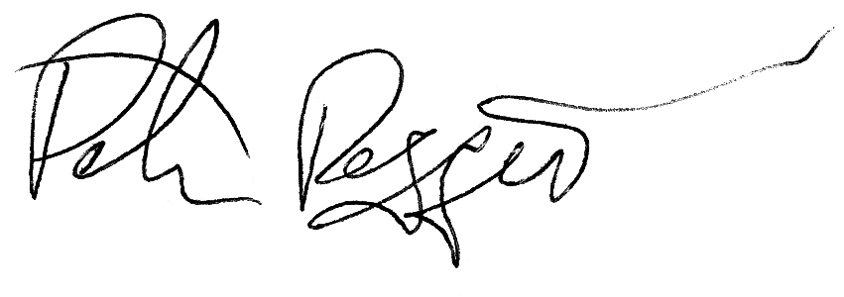
Peter Reggio
Race Management Coordinator
for the NOOD Regattas
13 May, 2010
1100hrs

