The Sperry Top-Sider National Offshore One-Design Regatta Presented by Mount Gay Rum and Sailing World

2010 Divisions, Classes and Class Flags

Class Flags are International Code Flags depicted in RRS Race Signals. The Class Flag Illustration shown here may not be an accurate color reproduction.
Division A

Division | Class |  | Class Flag | Class Flag Illustration | Course Reader Board Row
A |  | J-109 | 1 | 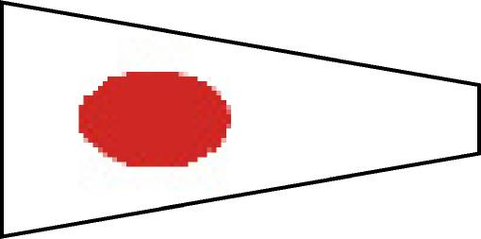 | Top
A |  | Beneteau 36.7 | 2 | 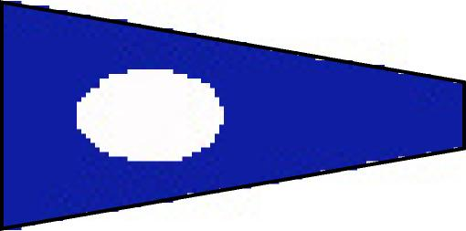 | Top
A |  | J-105 | 3 | 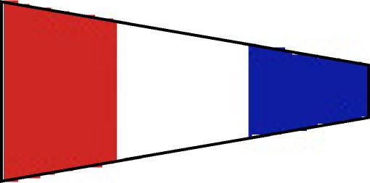 | Middle
A |  | Performance 30 | 4 | 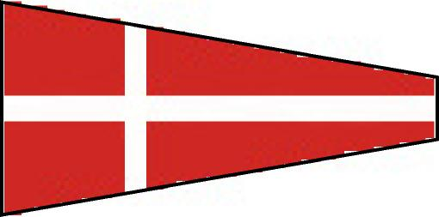 | Middle
A |  | J-24 | 5 | 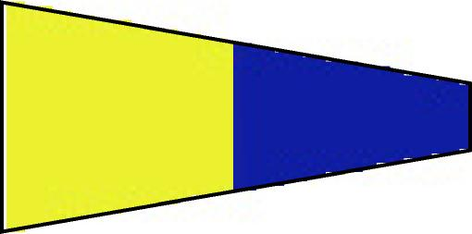 | Bottom
A |  | T-Bird | 6 | 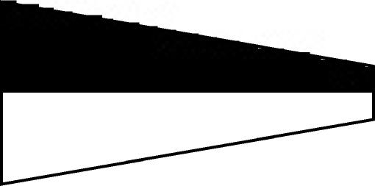 | Bottom

2010 Divisions, Classes and Class Flags

Class Flags are International Code Flags depicted in RRS Race Signals. The Class Flag Illustration shown here may not be an accurate color reproduction.
Division B

Division | Class | Class Flag | Class Flag Illustration | Course Reader Board Row
B | Melges 24 | 1 |  | Top
B | Open Sportboat | 2 |  | Top
B | Ultimate 20 | 3 |  | Top
B | San Juan 24 | 4 |  | Middle
B | Santana 20 | 5 |  | Middle
B | San Juan 21 | 6 |  | Middle

2010 Divisions, Classes and Class Flags

Class Flags are International Code Flags depicted in RRS Race Signals. The Class Flag Illustration shown here may not be an accurate color reproduction.

Division C

Division | Class | Class Flag | Class Flag Illustration | Course Reader Board Row
C | F-18 | 1 |  | Top
C | A-Cat &  Moth | 2 |  | Top
C | 505 | 3 |  | Top
C | 29’er / Open Skiff | 4 |  | Top
C | Thistle | 5 |  | Bottom
C | Vanguard - 15 | 6 |  | Bottom
C | Laser &  Radial | 7 | 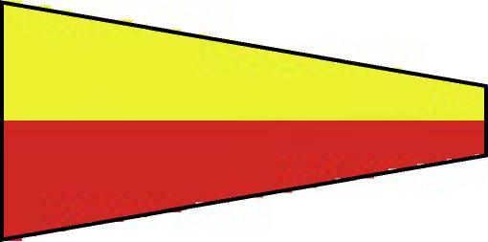 | Bottom
C | Tasar | 8 | 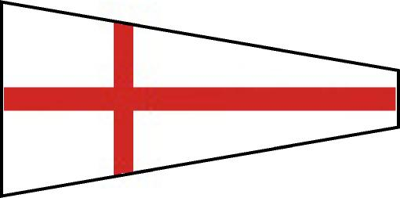 | Bottom

Note: Mini-12 Fleet will Race on Lake Union
Division | Class | Class Flag | Class Flag Illustration | Course Reader Board Row
D | Mini - 12 | 1 |  | N/A

