Star & Bar Regatta
September 19-20, 2009

Classes and Class Flags

Class | Rating / OD | Class Flag | Class Flag Illustration | Course Readerboard Row
1 | PHRF | Number 1 | 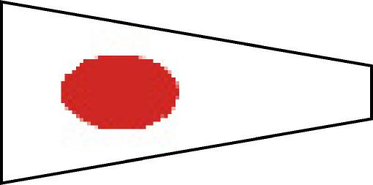 | Top
2 | PHRF | Number 2 | 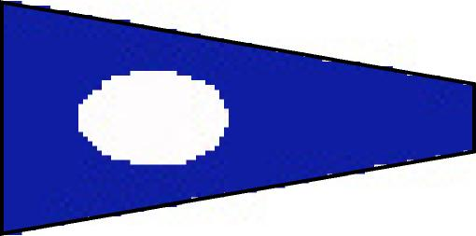 | Middle
3 | PHRF | Number 3 | 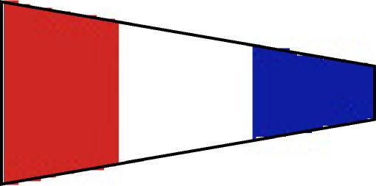 | Middle
4 | J-105 OD | Number 4 | 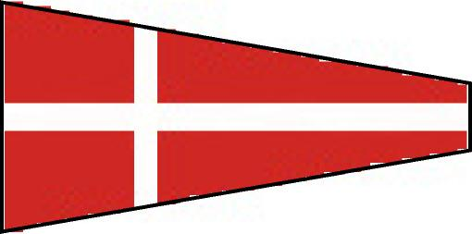 | Middle
5 | PHRF | Number 5 | 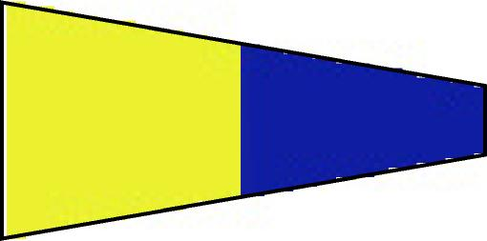 | Bottom
6 | PHRF | Number 6 | 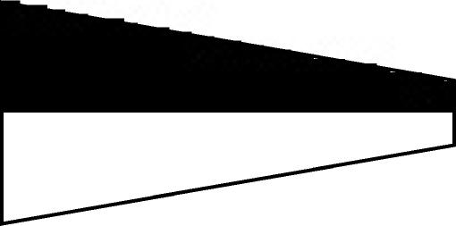 | Bottom

