2nd Amendment to 2009 Mark Mayer Sailing Instructions

Two additions:

1. Add 9.7 to the existing Sailing Instructions.

9.7 The reader board row designation for each class – either top, middle, or bottom – will be posted with the classes and class flags.

2. Add ReaderBoard Row designation on Attachment B as shown below:

Attachment B: Classes and Class Flags

Class Flags are International Code Flags depicted in RRS Race Signals. The Class Flag Illustration shown here may not be an accurate color reproduction.

Class | Class Flag | Class Flag Illustration | Class Description | Reader Board Row
1 | Pennant 1 | 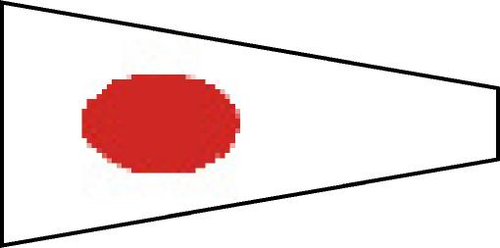 | PHRF 1 | Top
2 | Pennant 2 | 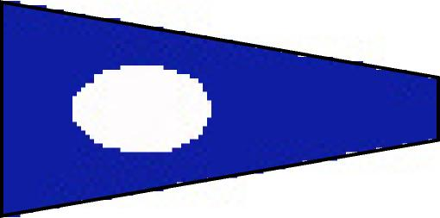 | PHRF 2 | Middle
3 | Pennant 3 | 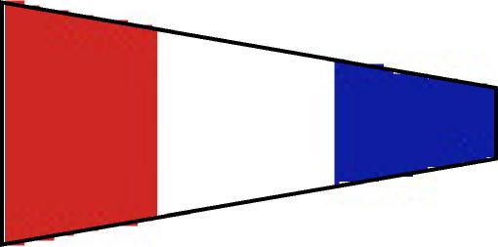 | Racer / Cruiser  (FS & NFS) | Middle
4 | Pennant 4 | 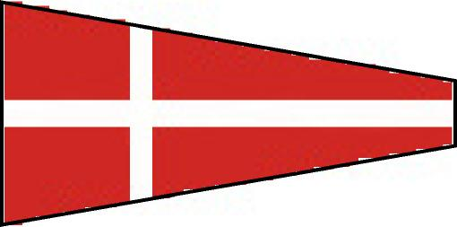 | T- Bird Class | Bottom
5 | Pennant 5 | 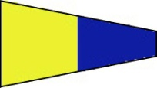 | Not assigned | Bottom

Posted 1100 5/2/09

Brian Ledbetter
Sailing Director, SYC

