Mark Mayer Regatta
May 3, 2009

Sailing Instructions

1 RULES

1.1 This regatta will be governed by the rules as defined in the Racing Rules of Sailing (RRS).

1.2 The prescriptions of US Sailing to the following rules shall apply: 34, 40, 48, 55, 61.4, 64.3(b), 68, 70.5(a), 76.1, 76.3, 82, 86.3, 88.2, Appendix F, and Appendix G2.

1.3 A boat rated by PHRF Northwest handicap rating class in consideration of water ballast will be allowed to use water ballast as rated. This changes RRS 51.

1.4 Other changes to the RRS are noted elsewhere in these sailing instructions.

2 NOTICE TO COMPETITORS

2.1 Notices to competitors will be posted on the official notice board.

2.2 The official notice board will be located at the south entrance of SYC Portage Bay clubhouse and optionally on the SYC web site at www.seattleyachtclub.org.

2.3 The race committee may provide unofficial communication at any time by hail or over VHF 72. Any communication that is not defined by the rules is unofficial communication. No aspect of unofficial communication, including content, timeliness, existence, or failure to hear, will be grounds for a request for redress. This changes RRS 62.1(a).

3 CHANGES TO SAILING INSTRUCTIONS

3.1 Change to the Sailing Instructions will be posted on the official notice board before 0900 hours on the day it will take effect, except that any change in the schedule of races will be posted by 1800 hours on the day before it will take effect.

3.2 The race committee intends to repeat changes in sailing instructions on VHF 72 fifteen minutes before the scheduled time of the first warning signal each day. No aspect of this announcement, including content, timeliness, existence, or failure to hear, will be grounds for a request for redress. This changes RRS 62.1(a).

4 SCHEDULE OF RACES

4.1 Date of the race is Sunday, May 3, 2009.

4.2 One race is scheduled.

4.3 The scheduled time of the first warning signal is 1200 hours.

4.4 No warning signal will be made after 1500 hours.

5 SIGNALS MADE ASHORE

5.1 There is no provision for signals made ashore.

6 RACING AREA AND RACE COMMITTEE SIGNAL BOAT

6.1 The racing area is Lake Washington in the vicinity of Sand Point.

6.2 The starting line and finishing line will be in the area between Webster Point, Hunts Point, and Sand Point.

6.3 The race committee signal boat will be the Seattle Yacht Club M/V Portage Bay. If necessary an alternate race committee signal boat may be used. The race committee signal boat will fly the SYC burgee and a blue “R/C” flag.

7 CLASSES AND CLASS FLAGS

7.1 The classes to race are PHRF-NW, including Cruiser/Racer, and keelboat one-design.

7.2 The classes and class flags are shown in Attachment B: Classes and Class Flags.

7.3 Class assignments for registered boats will be handled as a notice to competitors issued by 0900 hours before the race.

8 ADDITIONAL IDENTIFICATION

8.1 Boats may fly their class flag from their backstay or the highest point on their stern while racing. Boats may not fly a numeral pennant for another class while racing.

9 COURSES

9.1 Courses will be signaled from a reader board on the race committee signal boat.

9.2 A course description on the reader board will be a series of letters on one row indicating the marks and their required sequence. The first letter displayed is the starting mark, the last letter is the finishing mark, and the letters between are the rounding marks.

9.3 The marks and course configurations are as shown as in "Attachment A: Mark Descriptions and Course Diagram"

9.4 All rounding marks shall be left to port.

9.5 After completing the first leg of the course, a boat shall not cross the finishing line unless she is finishing. A boat that fails to observe this restriction may exonerate herself by taking a two turns penalty as described in RRS 44.2. This changes RRS 28.1. A boat that fails to exonerate herself will be scored DNF without a hearing. This changes RRS 63.1 and Appendix A5. The finishing line is an obstruction for boats required to keep clear.

9.6 The race committee may shorten the course or abandon the race for individual classes by including the class flags for affected classes under the flags required by RRS 32. This amends RRS 32. 9.3

9.7 The reader board row designation for each class -- either top, middle, or bottom -- will be posted with the classes and class flags.

10 THE START

10.1 The starting line will be between a staff displaying an orange flag on the race committee signal boat and the course side of the starting mark.

10.2 If the warning signal for a succeeding class is made with the starting signal of a preceding class, and if the preceding class has a general recall, then the class flag of the succeeding class will be removed and the start of the succeeding class will be considered abandoned without further signal.

10.3 If a boat is subject to RRS 29.1, Individual Recall, or RRS 30, Starting Penalties, the race committee may attempt to hail her sail number directly and/or on VHF channel 72. No aspect of the hail, including content, timeliness, existence, or failure to hear, will be grounds for a request for redress. This changes RRS 62.1(a).

10.4 A boat starting later than ten minutes after her starting signal will be scored Did Not Start (DNS). This changes RRS A4.2 and A5.

10.5 A boat whose warning signal has not been made shall avoid the starting area when other boats are racing but have not yet started.

10.6 The race committee signal boat may maneuver to hold position on the starting line with engine, including while anchored.

11 THE FINISH

11.1 The finishing line will be between a staff displaying a blue flag on the race committee signal boat and the course side of the finishing mark.

11.2 The race committee may adjust or maintain the position of the finishing mark at any time without regard to RRS 33. If a race committee boat is attached to the finishing mark while boats are on the last leg of the course, that race committee boat shall display flag M as in RRS 34(b), but shall not be required to make repetitive sound signals. This changes RRS 33 and 34.

11.3 The race committee signal boat may maneuver to adjust or maintain the size and orientation on the finishing line with engine at any time, including when anchored. This changes RRS 33 and 34.

12 TIME LIMIT

12.1 The time limit is the maximum allowable time from each boat’s starting signal to her finish time.

12.2 The time limit is 2 hours.

12.3 Boats that do not finish within their time limit will be scored Did Not Finish (DNF). This changes RRS 35.

13 PROTESTS

13.1 A boat intending to protest or request redress for an incident that occurred while racing shall orally notify the race committee signal boat as soon as possible after retiring or finishing by hail or VHF 72. This changes RRS 61.

13.2 Written protests must be delivered to the front desk of the SYC Portage Bay clubhouse within the protest time limit.

13.3 The time of the protest time limit will be posted on the official notice board after the docking of the race committee signal boat. The protest time limit is 30 minutes after the docking of the race committee signal boat or 15 minutes after the posting of the time of the time limit, whichever is greater.

13.4 Hearing notices will be posted on the official notice board within 5 minutes after the protest time limit to inform parties to a hearing of the time and place of the hearing. Hearings may commence at any time if parties are present and prepared; otherwise hearings may be scheduled as early as 10 minutes after the protest time limit. The posting of hearing notices shall be considered notice as required by RRS 63.2.

13.5 A boat may not protest another boat for an alleged breach of sailing instructions 10.5 and 13. This changes RRS 60.1(a).

13.6 Penalties under sailing instructions 10.5, 13, and 15 may be less than disqualification. This changes RRS 64.1(a).

14 SCORING

14.1 Boats will be scored in class and overall.

14.2 A boat that did not start (DNC, DNS, OCS), did not finish (DNF), retired after starting, retired after finishing (RAF), or is disqualified (DSQ, DNE, DGM, BFD) will be scored the number of finishers plus one. This changes RRS Appendix A4.2 and A9.

14.3 For PHRF classes, corrected times will be calculated using the Time on Time method as defined by PHRF Northwest. The “A Factor,” which does not impact results, will equal the “B Factor.” The "B Factor" for each race will be determined by the race committee, using the following criteria:

Conditions Approx. Average Winds B Factor
Light Winds 0 to 7 knots 650
Medium Winds 8 to 14 knots 550
Heavy Winds 15+ knots 480

The race committee's judgment in applying this criteria shall not be grounds for a request for redress.

15 SAFETY REGULATIONS AND CONSIDERATIONS

15.1 Boats shall check in with the race committee signal boat at the starting area before racing.

15.2 Boats that retire from the race shall orally notify the race committee as soon as possible after retiring by hail or VHF 72.

15.3 Boats racing in PHRF classes must comply with the then current Pacific International Yachting Association (PIYA) Special Regulations Governing Minimum Equipment and Accommodation Standards according to the race category requirements identified below. The text of the PIYA regulation is available from Seattle Yacht Club, other PIYA member yacht clubs, and the PIYA web site at www.ussailing.net/piya . Category requirements are as follows: PIYA Category III.

15.4 For the purpose of interpreting PIYA regulation 3.8, the study located at www.ussailing.org/safety/Studies/radar_reflector_test.htm will serve as a guide. Furthermore, radar reflectors with minimum dimension of less than 6 inches will be considered unlikely to meet the requirement.

15.5 Boats must comply with U.S. Coast Guard regulations.

15.6 The race committee may inspect a boat or its equipment at any time before or after racing for compliance with safety requirements.

15.7 It is recommended that all participants wear personal flotation devices (PFDs) while on the water.

15.8 A boat that uses its propulsion engine under RRS 1.1 and 42.3(f) or to move to a safe position if it is in danger of being run down by a vessel not participating in the race must either retire or file a request for redress. The request for redress must include the reason for using the propulsion engine and distance and direction traveled. When hearing the request for redress the protest committee will adjust the boat’s time or score to remove any advantage that may have been gained in the race. This defines the circumstances in RRS 42.3(h) and changes RRS 62.1 and 64.2. This does not restrict a boat from requesting redress under RRS 62.1(c) for the same incident.

16 DISCLAIMER OF LIABILITY

16.1 Competitors participate in the regatta entirely at their own risk. See RRS 4, Decision to Race. The organizing authority, Seattle Yacht Club, will not accept any liability for material damage or personal injury or death sustained in conjunction with or prior to, during, or after the regatta. It is the responsibility of each skipper to competently inform their crew of the risks of sailboat racing, to make sure their crew understands and accepts those risks, to decide whether their crew is competent and their equipment adequate for the event, and to decide whether to start or continue in a race.

17 AWARDS

17.1 Awards for first, second, and third in class. The location of the awards ceremony will at the SYC Portage Bay clubhouse after racing.

Attachment A: Mark Descriptions and Course Diagram

The following course diagram depicts the general orientation of the marks (identified by the letters S, A, X, Z, B, U, and F), the race committee signal boat ("R/C"), and the wind. All marks are inflatable buoys with the color as shown on the diagram. The diagram is not drawn to scale and the positions are only approximate.

Mark Descriptions Course Diagram

S Red or orange starting mark (may also be used as a finishing mark)
A
(Yellow)
X
(Red)
S
(Red or Orange)
F
(Yellow)
B
(Yellow)
U
(Red)
Z
(Red)
R/C
Intended
Wind Direction
C
(Yellow)

A Yellow mark to windward of race committee signal boat

B Yellow gybe mark

C Yellow mark to leeward of the race committee signal boat

X Red mark to windward of race committee signal boat

Z Red mark to windward of race committee signal boat, within approx. 0.2 nautical miles

U Red mark to leeward of the race committee signal boat

F Yellow finishing mark
Attachment B: Classes and Class Flags

Class Flags are International Code Flags depicted in RRS Race Signals. The Class Flag Illustration shown here may not be an accurate color reproduction.

Class | Class Flag | Class Flag Illustration | Class Description | Reader Board Row
1 | Pennant 1 | 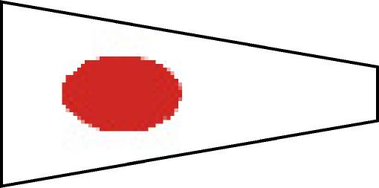 | PHRF 1 | Top
2 | Pennant 2 | 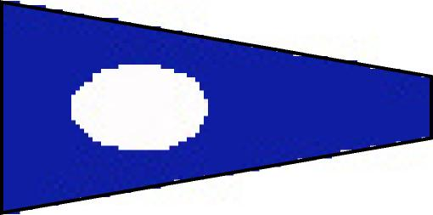 | PHRF 2 | Middle
3 | Pennant 3 | 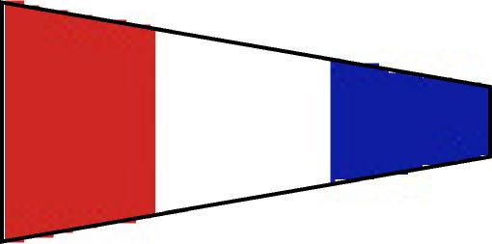 | Racer / Cruiser  (FS & NFS) | Middle
4 | Pennant 4 | 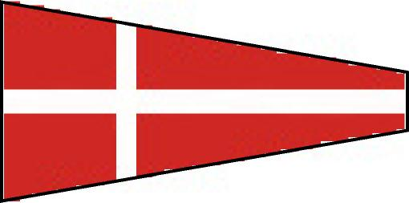 | T- Bird Class | Bottom
5 | Pennant 5 | 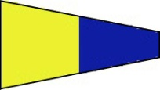 | Not assigned | Bottom

