Jack & Jill Race
June 13, 2009

Sailing Instructions

1 RULES

1.1 This regatta will be governed by the rules as defined in the Racing Rules of Sailing (RRS).

1.2 The prescriptions of US Sailing to the following rules shall apply: 34, 40, 48, 55, 61.4, 64.3(b), 68, 70.5(a), 76.1, 76.3, 82, 86.3, 88.2, Appendix F, and Appendix G2.

1.3 A boat rated by PHRF Northwest handicap rating class in consideration of water ballast will be allowed to use water ballast as rated. This changes RRS 51.

1.4 Other changes to the RRS are noted elsewhere in these sailing instructions.

2 NOTICE TO COMPETITORS

2.1 Notices to competitors will be posted on the official notice board.

2.2 Prior to the start of the race the official notice board will be located at the east entrance of the Corinthian Yacht Club Shilshole clubhouse and optionally on the Seattle Yacht Club web site at www.seattleyachtclub.org. After the start of the race the official notice board will be located outside the south entrance of the Seattle Yacht Club Portage Bay clubhouse and optionally on the Seattle Yacht Club web site at www.seattleyachtclub.org.

2.3 The race committee may provide unofficial communication at any time by hail or over VHF 72. Any communication that is not defined by the rules is unofficial communication. No aspect of unofficial communication, including content, timeliness, existence, or failure to hear, will be grounds for a request for redress. This changes RRS 62.1(a).

3 CHANGES TO SAILING INSTRUCTIONS

3.1 Changes to the Sailing Instructions will be posted on the official notice board by 1045 on the day of the race.

3.2 The race committee intends to repeat changes in sailing instructions on VHF 72 fifteen minutes before the scheduled time of the first warning signal. No aspect of this announcement, including content, timeliness, existence, or failure to hear, will be grounds for a request for redress. This changes RRS 62.1(a).

4 SCHEDULE OF RACES

4.1 The date of the race is June 13, 2009.
4.2 One race is scheduled.

4.3 A skipper’s meeting will be at 1030 hours at the Corinthian Yacht Club Shilshole clubhouse.

4.4 The scheduled time of the first warning signal is 1200 hours.

4.5 No warning signal will be made after 1500 hours.

5 SIGNALS MADE ASHORE

5.1 Signals made ashore will be displayed from the race committee signal boat while moored near the Corinthian Yacht Club clubhouse.

5.2 When flag AP is displayed ashore, the warning signal will be made not less than 60 minutes after the removal of AP unless at that time the race is postponed again or abandoned. This changes RRS Race Signals AP.

6 RACING AREA AND RACE COMMITTEE SIGNAL BOAT

6.1 The racing area is Puget Sound north of Alki Pt. and south of Pt. Wells.

6.2 The starting line will be in Shilshole Bay in the area between Meadow Point and the Shilshole Bay Approach Buoy. If the finishing mark is mark “F” then the finishing line will be in the same area as the starting line. If the finishing mark is not mark “F” then the finishing line will be at the last mark of the course.

6.3 The race committee signal boat will be the Seattle Yacht Club M/V Portage Bay. If necessary an alternate race committee signal boat may be used. The race committee signal boat will fly the Seattle Yacht Club burgee and a blue “R/C” flag.

7 CLASSES

7.1 The classes to race are PHRF Northwest classes.

7.2 The classes and class flags are shown in Attachment B: Classes and Class Flags.

7.3 There will be three classes: Jack & Jill (crew of one male and one female), Double Handed (two crew total), and Single Handed (one crew total). The entrants in the Jack & Jill class will also be entrants in the Doublehanded class.

7.4 A boat representative must attend the skipper’s meeting to select their class or report at the race committee signal boat prior to the first warning.

8 ADDITIONAL IDENTIFICATION

8.1 Boats may fly their class flag from their backstay or the highest point on their stern while racing. Boats may not fly a numeral pennant for another class while racing.

9 COURSES

9.1 Courses will be signaled from a reader board on the race committee signal boat.

9.2 A course description on the reader board will be a series of letters on one row indicating the marks and their required sequence. The first letter displayed is the starting mark, the last letter is the finishing mark, and the letters between are the rounding marks.
9.3 The marks are as specified in "Attachment A: Mark Descriptions"

9.4 Marks identified on the reader board with a red letter shall be left to port and marks identified on the reader board with a green letter shall be left to starboard.

9.5 After completing the first leg of the course, a boat shall not cross the finishing line unless she is finishing. A boat that fails to observe this restriction may exonerate herself by taking a two turns penalty as described in RRS 44.2. This changes RRS 28.1. A boat that fails to exonerate herself will be scored DNF without a hearing. This changes RRS 63.1 and Appendix A5. The finishing line is an obstruction for boats required to keep clear.
9.6 The race committee may shorten the course or abandon the race for individual classes by including the class flags for affected classes under the flags required by RRS 32. This amends RRS 32.

10 THE START

10.1 The starting line will be between a staff displaying an orange flag on the race committee signal boat and the course side of the starting mark.

10.2 If the warning signal for a succeeding class is made with the starting signal of a preceding class, and if the preceding class has a general recall, then the class flag of the succeeding class will be removed and the start of the succeeding class will be considered abandoned without further signal.

10.3 If a boat is subject to RRS 29.1, Individual Recall, or RRS 30, Starting Penalties, the race committee may attempt to hail her sail number directly and/or on VHF 72. No aspect of the hail, including content, timeliness, existence, or failure to hear, will be grounds for a request for redress. This changes RRS 62.1(a).

10.4 A boat starting later than ten minutes after her starting signal will be scored Did Not Start (DNS). This changes RRS A4.2 and A5.

10.5 A boat whose warning signal has not been made shall avoid the starting area when other boats are racing but have not yet started.

10.6 The race committee signal boat may maneuver to hold position on the starting line with engine, including while anchored.

11 THE FINISH

11.1 The finishing line will be between a staff displaying an orange flag on the race committee signal boat and the course side of the finishing mark.

11.2 The race committee may adjust or maintain the position of the finishing mark at any time without regard to RRS 33. If a race committee boat is attached to the finishing mark while boats are on the last leg of the course, that race committee boat shall display flag M as in RRS 34(b), but shall not be required to make repetitive sound signals. This changes RRS 33 and 34.

11.3 The race committee signal boat may maneuver to adjust or maintain the size and orientation of the finishing line with engine at any time, including when anchored. This changes RRS 33 and 34.

12 TIME LIMIT

12.1 The time limit is the maximum allowable time from each boat’s starting signal to her finish time.
12.2 The time limit is 4 hours.

12.3 Boats that do not finish within their time limit will be scored Did Not Finish (DNF). This changes RRS 35.

13 PROTESTS

13.1 A boat intending to protest or request redress for an incident that occurred while racing shall orally notify the race committee signal boat as soon as possible after retiring or finishing by hail or VHF 72 until she receives an oral confirmation from the race committee that the notification was received This changes RRS 61.

13.2 Written protests and requests for redress shall be delivered to the front desk of the Seattle Yacht Club Portage Bay clubhouse within the protest time limit.

13.3 The protest time limit is 1800 hours on Sunday after the regatta.

13.4 Hearing notices will be posted on the official notice board by 1200 hours on Tuesday after the regatta to inform parties to a hearing of the parties, time, and place of the hearing. The posting of hearing notices shall be considered notice as required by RRS 63.2.

13.5 Hearings will be held starting as early as 1900 hours on Tuesday after the regatta at the Seattle Yacht Club Portage Bay clubhouse.

13.6 A boat may not protest another boat for an alleged breach of sailing instructions 10.5 and 13. This changes RRS 60.1(a).

13.7 Penalties under sailing instructions 10.5, 13, and 15 may be less than disqualification. This changes RRS 64.1(a).

14 SCORING

14.1 Boats will be scored in class.

14.2 A boat that did not start (DNC, DNS, OCS), did not finish (DNF), retired after starting, retired after finishing (RAF), or is disqualified (DSQ, DNE, DGM, BFD) will be scored the number of finishers plus one. This changes RRS Appendix A4.2 and A9.

14.3 For PHRF classes, corrected times will be calculated using the Time on Distance method.

14.4 Boats may elect to use flying sails or not during the race. Boats will be rated for flying sails by default. Boats will be rated for non-flying sails if they do not use flying sails and immediately after finishing report to the race committee signal boat that they did not use flying sails.
14.5 Boats that are in the Jack & Jill class will also be scored in the Double Handed class.

14.6 This race is part of the Puget Sound Jack & Jill series.

15 SAFETY REGULATIONS AND CONSIDERATIONS

15.1 Boats shall check in with the race committee signal boat at the starting area before the first warning.

15.2 Boats that retire from the race shall orally notify the race committee as soon as possible after retiring by hail or VHF 72.

15.3 Boats racing in PHRF classes must comply with the then current Pacific International Yachting Association (PIYA) Special Regulations Governing Minimum Equipment and Accommodation Standards according to the race category requirements identified below. The text of the PIYA regulation is available from Seattle Yacht Club, other PIYA member yacht clubs, and the PIYA web site at www.ussailing.net/piya . Category requirements are as follows: PIYA Category III.

15.4 For the purpose of interpreting PIYA regulation 3.8, the study located at http://www.ussailing.org/safety/Studies/radar_reflector_test.htm will serve as a guide. Furthermore, radar reflectors with minimum dimension of less than 6 inches will be considered to not meet the requirement.

15.5 Boats must be operated in accordance with the Puget Sound Sailboat Safety Regulations, available in the Seattle Yacht Club Sailboat Race Book.

15.6 Boats must comply with U.S. Coast Guard regulations.

15.7 The race committee may inspect a boat or its equipment at any time before or after racing for compliance with safety requirements.

15.8 Competitors are required to wear US Coast Guard certified personal flotation devices (PFDs) while on the water.

15.9 A boat that uses its propulsion engine under RRS 1.1 and 42.3(f) or to move to a safe position if it is in danger of being run down by a vessel not participating in the race must either retire or file a request for redress. The request for redress must include the reason for using the propulsion engine and distance and direction traveled. When hearing the request for redress the protest committee will adjust the boat’s time or score to remove any advantage that may have been gained in the race. This defines the circumstances in RRS 42.3(h) and changes RRS 62.1 and 64.2. This does not restrict a boat from requesting redress under RRS 62.1(c) for the same incident.

16 DISCLAIMER OF LIABILITY

16.1 Competitors participate in the regatta entirely at their own risk. See RRS 4, Decision to Race. The organizing authority, Seattle Yacht Club, will not accept any liability for material damage or personal injury or death sustained in conjunction with or prior to, during, or after the regatta. It is the responsibility of each skipper to competently inform their crew of the risks of sailboat racing, to make sure their crew understands and accepts those risks, to decide whether their crew is competent and their equipment adequate for the event, and to decide whether to start or continue in a race.

17 AWARDS

17.1 Awards for first, second, and third in class. The location of the awards ceremony will be announced at the skipper’s meeting.

Attachment A: Mark Descriptions

The following mark descriptions include buoy course marks in position relative to the race committee signal boat and Puget Sound marks in position based on geographic location.

Buoy Course Marks (position relative to race committee signal boat)
A
(Yellow)
X
(Red)
S
(Red or Orange)
F
(Yellow)
B
(Yellow)
U
(Red)
Z
(Red)
R/C
Intended
Wind Direction
C
(Yellow)

The course diagram for buoy course marks depicts the general orientation of the marks (identified by the letters S, A, B, C, X, Z, U and F), the race committee signal boat ("R/C"), and the wind. All marks are inflatable buoys with the color as shown on the diagram. The diagram is not drawn to scale and the positions are only approximate.

S Red or orange starting mark (may also be used as a finishing mark)
A Yellow mark to windward of race committee signal boat
B Yellow gybe mark
C Yellow mark to leeward of the race committee signal boat
X Red mark to windward of race committee signal boat
Z Red mark to windward of race committee signal boat, within approx. 0.2 nautical miles
U Red mark to leeward of the race committee signal boat
F Yellow finishing mark

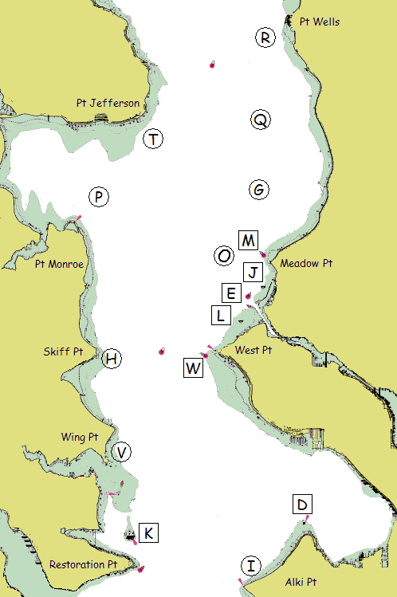
Puget Sound Marks (position based on geographic location)

Bearings are magnetic. Distances are in nautical miles (NM). Bearings and distances are approximate. Each temporary mark is shown with its label in a circle. Each permanent mark is near its label in a square box. Positions are approximate.

D Duwamish Head Lt. (LL #16910)
E Shilshole Bay Approach Buoy (LL #16785)
G Temporary mark 1.5 NM bearing 340° from Meadow Pt. Buoy
H Temporary mark 0.3 NM E of Skiff Pt.
I Temporary mark 0.5 NM N of Alki Pt.
J Shilshole Bay North Mooring Buoy 0.25 NM SSW of Shilshole Marina north entrance
K Blakely Rock (LL #16830)
L Shilshole Bay South Mooring Buoy 0.5 NM SW of Shilshole Marina south entrance
M Meadow Pt. Buoy (LL #16765)
O Temporary mark 0.75 NM bearing 250° from Meadow Pt. Buoy
P Temporary mark 0.75 NM NNE of Pt. Monroe
Q Temporary mark 3.0 NM bearing 340° from Meadow Pt. Buoy
R Temporary mark 0.5 NM SW of Pt. Wells
T Temporary mark 0.5 NM SE of Pt. Jefferson
V Temporary mark 0.3 NM NNE of Wing Pt.
W West Pt. Buoy (LL #16805)

Attachment B: Classes and Class Flags

Class Flags are International Code Flags depicted in RRS Race Signals. The Class Flag Illustration shown here may not be an accurate color reproduction.

Class | Class Flag | Class Flag Illustration | Class Description
1 | Number 1 | 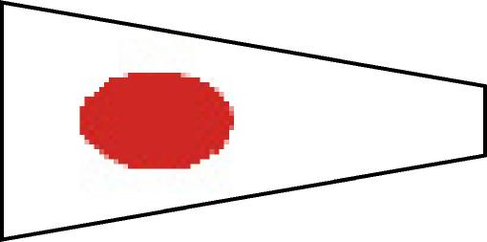 | Single Handed
2 | Number 2 | 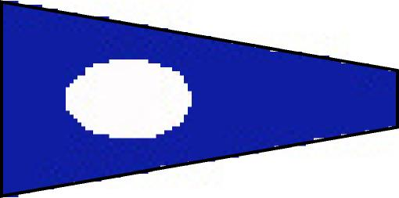 | Double Handed
3 | Number 3 | 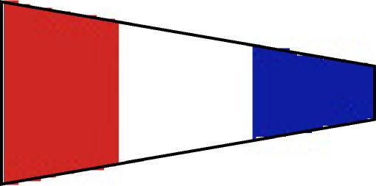 | Jack & Jill

